1. **Login**

The system has 2 main roles (admin and staff)

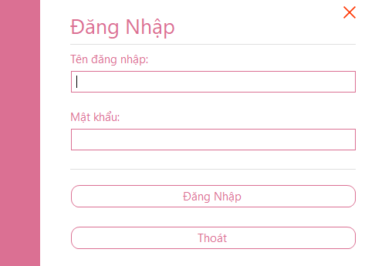1.1 login with manager account

Username: admin

Password: 1

1.2 login with staff account

Username: tanthanh

Password: 1

1. **Main Form**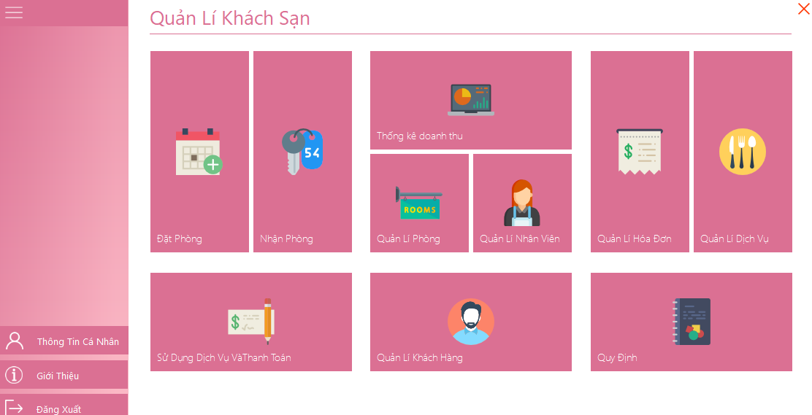
   1. At admin role, user can use all function
   2. At staff role, user can only user function ( Đặt Phòng, Nhận Phòng, Sử dụng dịch vụ và thanh toán, Thông tin cá nhân, Giới thiệu, Đăng xuất).
2. **Function “Đặt Phòng”.**

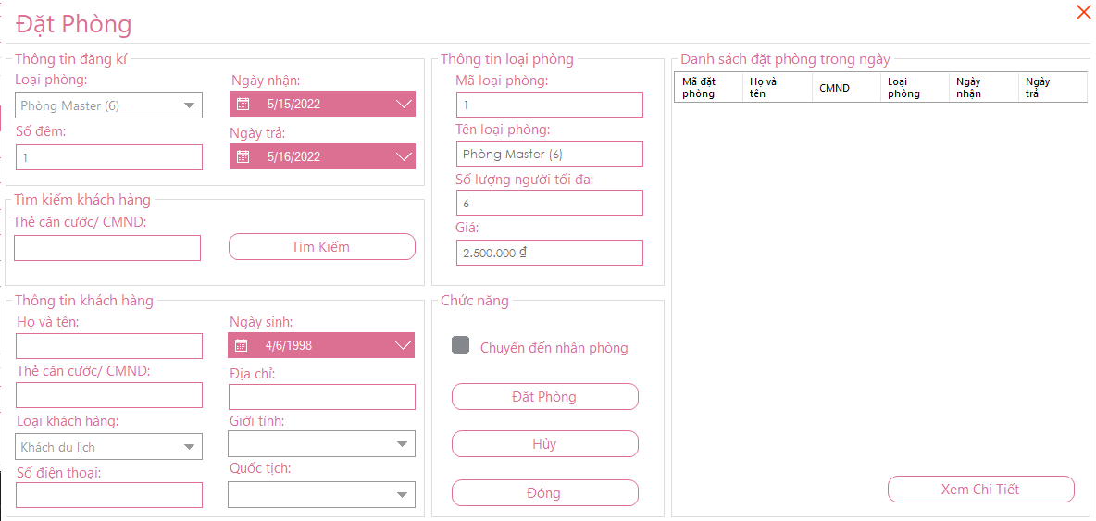

1. **Function “Nhận Phòng”.**

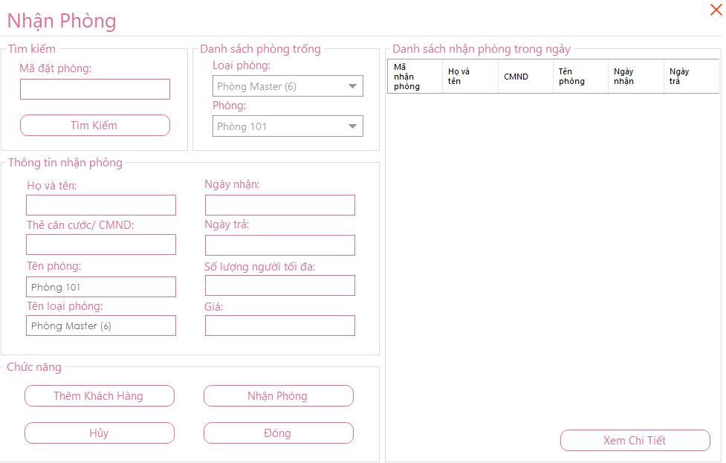

1. **Function “Sử dụng dịch vụ và thanh toán”.**

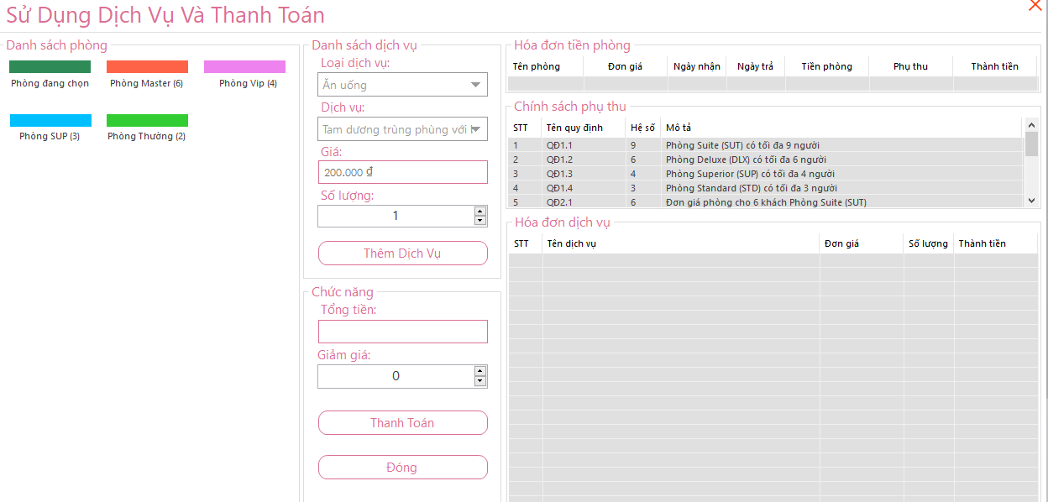

1. **Function “Thống kê doanh thu”.**

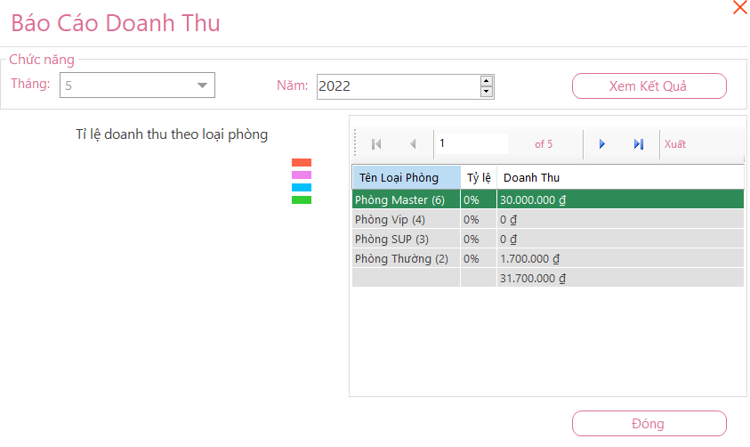

1. **Function “Quản lí phòng”.**

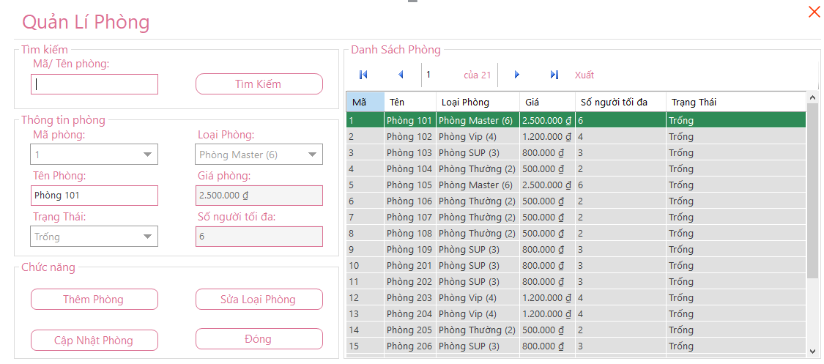

1. **Function “Quản lí nhân viên”.**

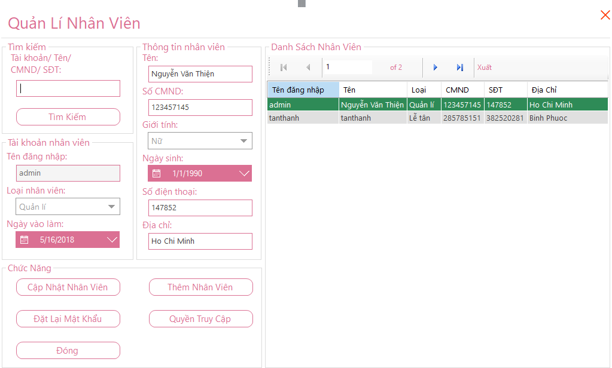

1. **Function “Quản lí khách hàng”.**

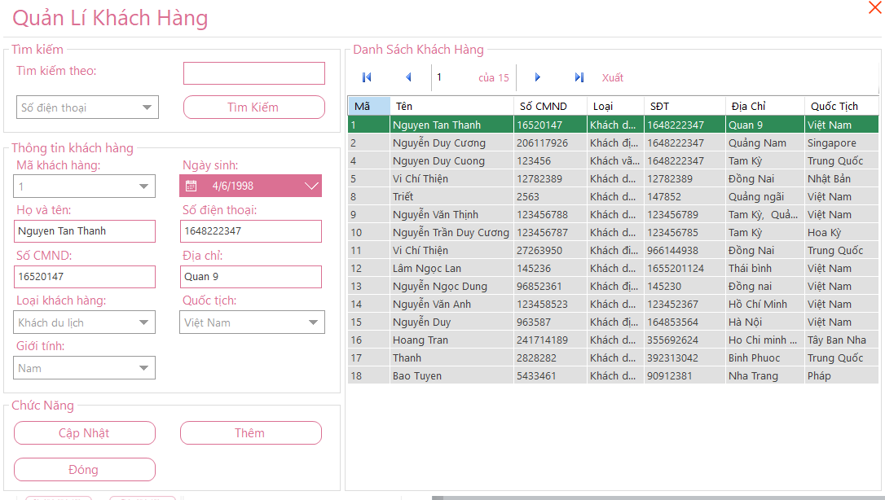

1. **Function “Quản lí hóa đơn”**.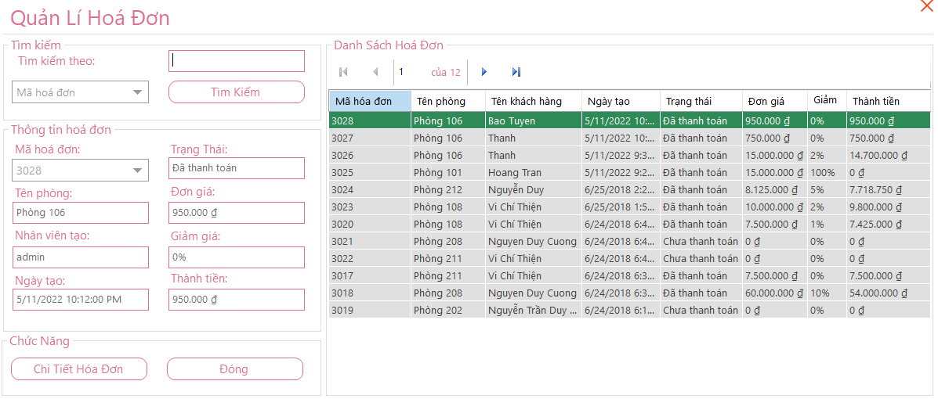
2. **Function “Quản lí dịch vụ”.**

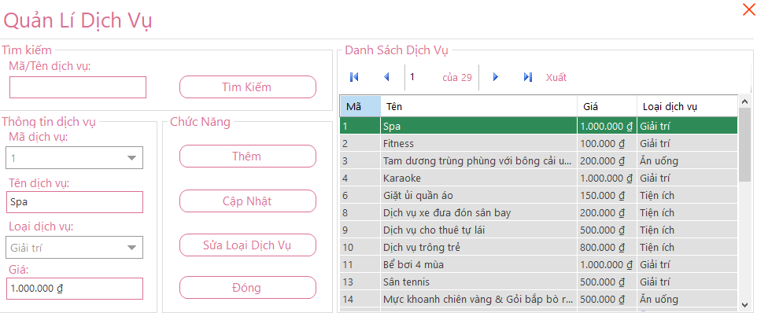

1. **Function “Qui định”.**

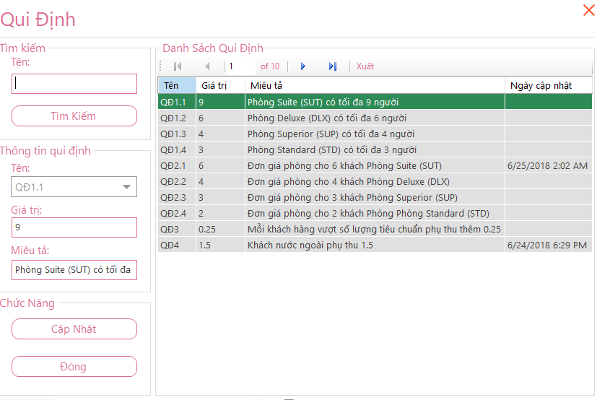

1. **Function “Thông tin cá nhân”**.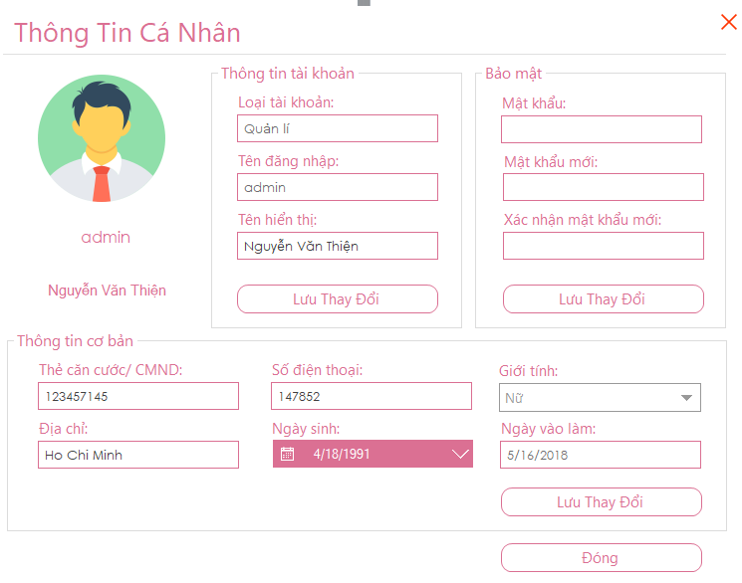
2. **Function “Giới thiệu”**.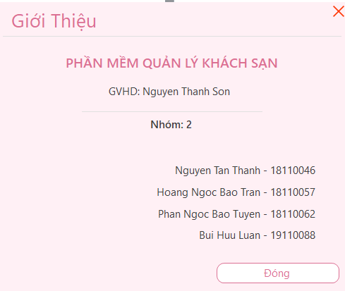
3. **Function “Đăng xuất”.**